University of Florida
Department of Electrical and Computer Engineering
EEL 5666 Intelligent Machines Design Laboratory

ROBI – Special Sensors Report
A detailed report of innovations in robotic sensing

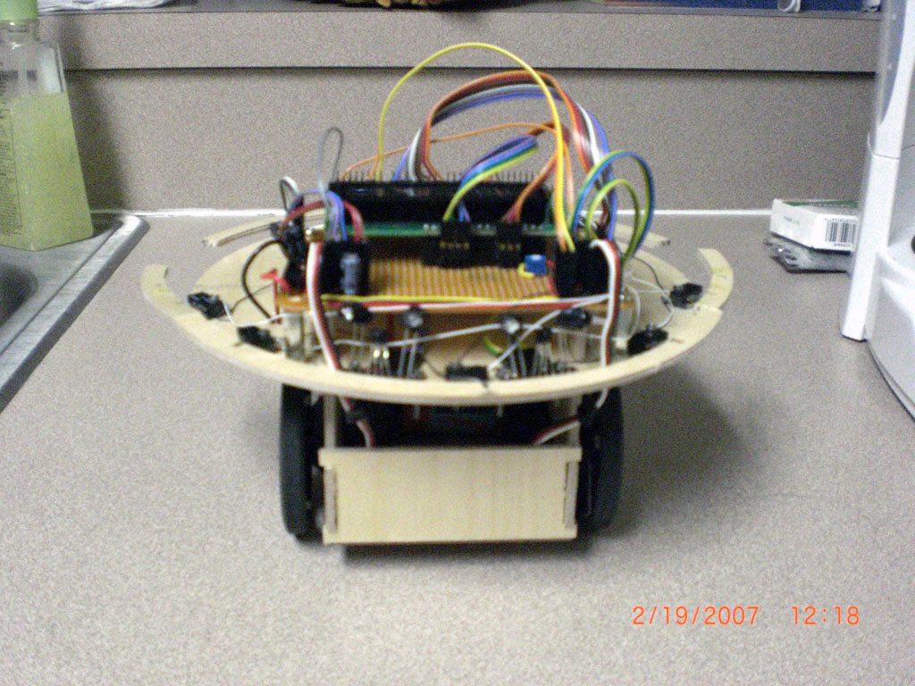
Robi: The parent of two smaller robotic children in the ROBI project
Introduction
The purpose of this document is to describe the design and functioning of several sensors that are either complete innovations or modifications of sensors commonly used in autonomous robotics. In each section I will give a brief background and then my solution or improvement.

Improvement in Common Sensors
Bump
Lever actuated switches are commonly used to surround a robot to give it a sense of touch. The general problem is how to connect these sensors to provide complete 360 degree coverage that will sense an obstacle of any size and at any incoming angle. Another concern is to minimize the force needed to trigger the switch.

The TJ Pro uses a flexible piece of wood that, when touched, triggers tactile switches. The problem with this approach is that a relatively great amount of force is needed to trigger the switch in certain positions. The connecting piece of wood must be flexible enough as to not add to the force needed. This system is shown in the picture below.
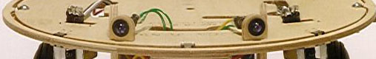
Courtesy of www.mekatronix.com

The Rug Warrior Pro is another common robotics platform. It uses several lever actuated switches that are not connected at all. Instead, a plastic dome is suspended around the robot. The dome, or skirt as they call it, is free to move in all directions with relative ease. However, the dome blocks sensors such as IR and Sonar so holes/windows must be cut out for each of these sensors. This design is also hard for the novice builder to replicate. This system is pictured below.
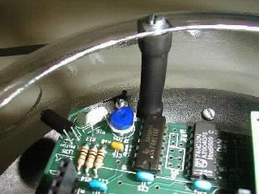
Courtesy of www.geocities.com/alanmcdonley/pogo.html

Below I describe how I tried to marry these two approaches to get the effectiveness of the skirt with the simplicity of a connecting ring. Levered switches were chosen because they had a ‘hair trigger’. Choosing a switch that is relatively hard to trigger to begin with would be futile (This is why the tactile ‘reset’ switch was not used).

A switch is placed roughly every 1 1/2” at most; in some situations a greater distance can be better. The main innovation is that the switches are free to rotate along an axis. Each switch has two holes that one may use M2 screws to secure them with; two axes to choose from. Their rotation is carefully chosen to close the switch when pressed on either side and the center. Not only must you consider the axis you choose but also the direction of the lever. The best way to find the most sensitive configuration is by experiment. Drill both holes for each lever and try all combinations.

I found that for a three switch combination shown below the best configuration is for all switches to be facing the same direction. The left and right switch should use the left axis while the middle switch can use either (one will be better if the switch is not centered properly).

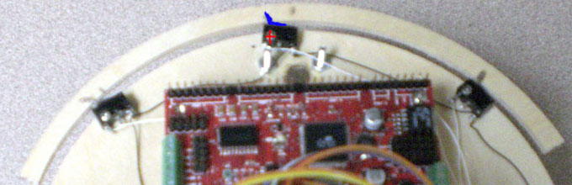

In the picture above the Red cross shows where a screw has been placed to secure the bump switch. It is not tight, however, which allows the switch to rotate on an axis making the sensor system much more sensitive. This also allows the connecting piece of wood to be inflexible. The lever of the bump switch is bent into a small cut out in the wood and then glued. The distance of wood extending free on the left and right should be kept to less than 1” (If more than 1” then space the switches farther apart).

Not shown here is a two switch configuration that needed to be used on the smaller 5” diameter children. Having each rotate on an axis and facing the same direction proved to be very sensitive in one direction but rigid in the other. Another downfall was that, mechanically, the levers could not hold the piece of wood from rotating vertically when an object was hit. The solution currently in use is to employ the TJ style configuration of fixed switches (levered).
However, I suspect that if the two switches are pointed in opposite directions with the lever sticking outwards then a great improvement would be made. The outer axis should be chosen for this configuration. This theoretical improvement is show below.

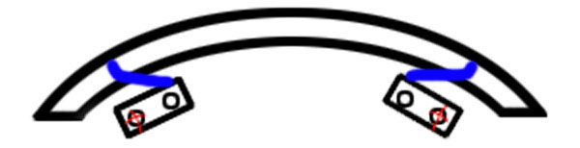

The bump switch shown to the side is different than the three configuration show before. The switch is fixed by way of a screw and nut. The switch can be rotated in or out by loosening the screw to let the level vary a certain distance away from the robot.
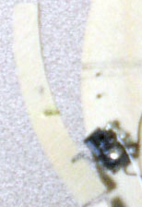 | These wings are good for feeling out things on the sides of the robot such as walls or small obstacles it didn’t see.  Special precautions must be taken however to make sure the switch doesn’t open (rotate counter-clockwise in the picture). This is done by way of a mechanical stop.  The wood should not extend past the part of the switch that the lever connects to the switch. The length that the wood extends in the other direction is only limited by mechanically stability and strength.

IR Sight for Obstacle Avoidance
Merits of interest in this area that will be discussed:
-Effective range in a normal lit indoor environment
-Cross talk between sensors
-Cost
-Affect of different colored objects

The basic sensor used is a Sharp IS471F Proximity Detector. This sensor
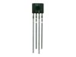 | generates a modulated signal that is ‘directly’ connected to an IR LED. The light of the LED bounces off an object back to the sensor to which the sensor will detect and output a corresponding digital signal. The sensor outputs a modulated signal of about 7.5kHz and a duty cycle of
6%. Each sensor has a little bit different carrier frequency and duty cycle. This along with the fact that the sensor is very sensitive to duty cycle and phase as well as the frequency makes cross talk almost a non-issue. Each sensor costs about $1-$2, along with the need for two 940nm IR LEDs. Hooked up as described in the datasheet the proximity detector has a range of about 2” off non-black surfaces. It does not detect black objects of any kind.

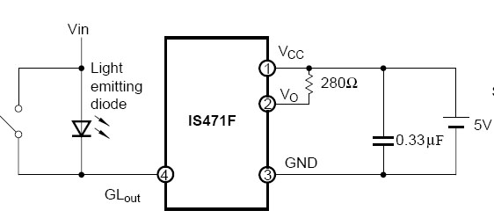  Basic Hookup | 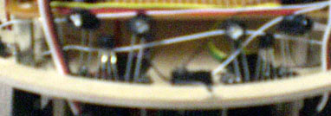  Two LEDs Plus Sensor Configuration

I will not talk about positioning of these sensors but suffice it to say that the detectors should be angled away from each other about 30 degrees from the center. Each detector should have two LEDs each facing about 15-20 degrees away from the detector. The setup shown above will give a dead-zone free field of view of about 180 degrees from just 6” away. However, first we need to boost the range of the sensor; this is my suggested improvement.

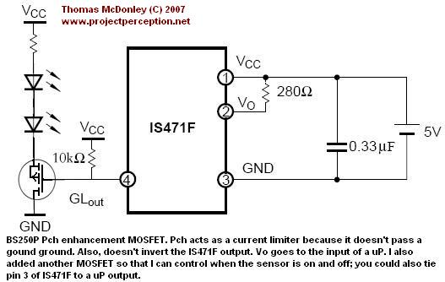
Sharp Proximity Detector with Boosted Range

The schematic above shows how to extend the range of the detector from 2” to about 1 foot for non-black surfaces. For surfaces that are black but a bit shinny the range is about 4-5”. This is a great improvement with little added effort or cost.

The unmarked resistor is a limiting resistor. Something as small as 10 Ohms will do quite well, but if you want to not use a resistor at all you gain a few inches without a big worry about burning out the LEDs for the following reasons.
The Pch MOSFET transistor doesn’t pass a good ground so it will not ‘open up’ completely; thus it acts as a built-in current limiter. The second, and Extremly Important, point is that GLout has a duty cycle of less than 10% which is ideal for pulsing diodes with a large amount of current for short periods of time.
As shown the LEDs are pulsed with about 200mA but up to 1A is acceptable for most LEDs (Check the datasheet for a max pulsed current rating).
A Pch enhancement mode MOSFET must be used because the detector is sensitive to the duty cycle. A Nch would invert the duty cycle from 6% to 94% (unless an inverter was used but this adds unneeded complexity). A duty cycle of 94% would also quickly burn out the diodes. Also an enhancement mode MOSFET is important because it allows the switch to open (be in saturation) with 5v(uP output) when Vcc could be as high as 12v.

The unmarked resistor can be used to vary the range of the sensor. If more than 1 foot is needed then a modification similar to that in the next section is needed.

Specially Designed Sensor

IR Beacons for Sight
In order to be able to see each other, the robots will have a special IR Beacon of my own design with a controllable range of up to 12ft. Each robot will have IR receivers encircling the mobile platform. The robots take turns (using different periods of repetition to prevent interference) sending out a modulated IR signal. If this signal reaches a receiver than the two robots know their orientation to each other. By varying the strength of the IR signal the robots then know the relative distance.

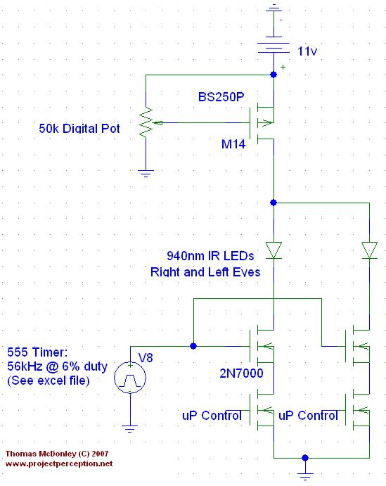 | The IR LEDs are pulsed with a current around 1A to ensure a maximum range of near 18ft. At the bottom of the schematic there is 4 n-channel MOSFETs. One is used to control the frequency and duty cycle and the other is used to control wheather or not the eye is on (by having independent control the motion of the robot can be more fluid and correct it’s path if the eyes see different things)  The potentiometer will control the gate voltage to a p-channel MOSFET. The gate is selected to have a wide saturation mode so that the current to the LEDs varies of a wide range of voltages. This also helps keep the readings linear.
The potentiometer is a digital pot so that it can be controlled with the microcontroller. Since the gate of a MOSFET doesn’t draw any current only one digital pot is needed to control the strength of all the beacons on the robot. There are many alternatives to using a digital pot but this gives the most control over LED intensity.

The receivers are simple Sharp gp1ue28 receivers. They are very sensitive so need to be shield both with a box to make them uni-directional and also with a separator between each to limit light leakage (see the figure below). Distance is measured by timing the first received pulse (weakest) to the last (strongest and guaranteed to be seen). This method was found to be almost linear and the readings are virtually the same on each of the 3 boards I made as well as with respect to position. The same parts should be used, shielding should be identical in nature and dimensions.

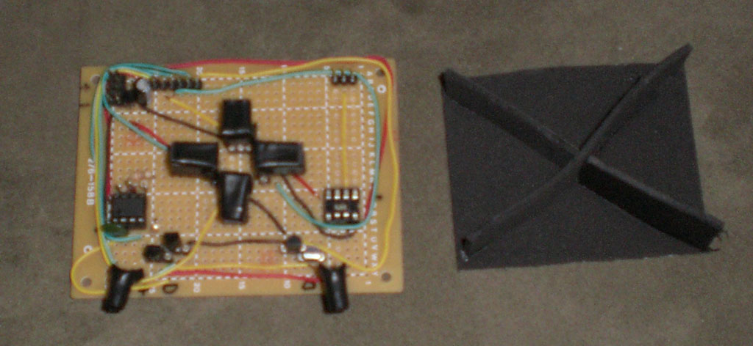
Some special considerations must be taken which include the fact that a low duty cycle needs to be generated and that the maximum range is a non-reflected rating.
First, the 555 timer in astable configuration is only capable of duty cycles of greater than 50%. In order to get a duty cycle of less than 50% (we need around 5%) we will need to hook a diode across R2. However, this makes the familiar 555 equations invalid because we must take into account the Diode. The simultaneous equations become much more complex. | 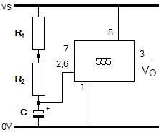
Thankfully, Phil Rogers of Texas Instruments has made an excel spread sheet that does all the calculations for you. This file can be found either on my site or in the Documentation section.

Lastly, it should be noted that this is a beacon setup. The range rating is unreflected and line of sight. The range of this design if used with the IS471F would vary but generally be around 4-5 feet.
Documentation
Intelligent Machine Lab @ UF
http://www.mil.ufl.edu/imdl/

IR Beacon
http://robotag.carleton.ca/resources/technical/ir_beacon.shtml

TJ Pro Maker
http://www.mekatronix.com/brief/robots.htm

Personal Pogo Website
http://www.geocities.com/alanmcdonley/pogo.html

Low Duty Cycle 555 Timer (Duty < 50%)
http://www.edn.com/index.asp?layout=article&articleid=CA238425
http://www.edn.com/contents/images/di2972.zip (Excel File)

Thomas McDonley Personal Website
http://www.projectperception.net
www.projectperception.net/ROBI.htm

